**AWS CodeBuild**

**Similar to Jenkins**

* Fully managed build service Integration
* Alternative to other build tools such as Jenkins
* Continous scaling [No CI server to manage or provision –no buid queue] [Internally it created docker container]
* Pay for usage : the time it takes to complete the build
* Leverages Docker Under the hood for reproducible build.
* Posibility to extend capabilities leveraging our own base docker images
* Secure: Integration with KMS for encryption of build artifacts, IAM for build permission, and vpc for network security, CloudTrail for API calls logging.

**Overview**

* Source code from Github /CodeCommit /CodePipeline /S3….
* Build Instructions can be defined in code [buildspec.yml file]
* Output logs to S3 and AWS cloud watch logs
* Metrics to monitor CodeBuild Statistics
* Use CloudWatch Events to detect failed builds and trigger notifications
* Use CloudWatch Alarms to notify if you need “threshold” for failures
* CloudWatch Events / AWS lambda as glue
* SNS notification

**How CodeBuild Works ?**

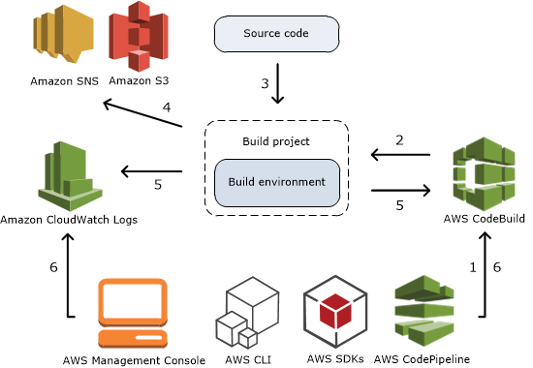

* **PROJECT CONFIGURATION**
* **SOURCE**
* **ENVIRONMENT**
* **BUILDSPEC**
* **ARTIFACTS**
* **LOGS**

**PROJECT CONGIGURATION**

* Project name &&&& Project description

**SOURCE CODE CONFIGURATION**

* Provide source code url branch and branch name. It supports GITHUB , S3 and other repo as well.

**ENVIRONMENTAL SETUP …for DOCKER**

* Managed Image or Custom Docker image
* Operating System
* Runtime : Standard
* Service Role: Create new or choose existing
* VPC and Env varaibles

**BUILD SPEC**

* Use a BuildSpec yaml file or Insert Build commands

 

**ARTIFACTS && S3**

* Create S3 Bucket and pass the bucket name in Artifact section.
* Artifacts Packaging : Zip
* Select Allow service role permission

**LOGS**

* Logs can be stored in **S3 and Cloud Watch**
* Select Allow service role permission

**Cloud watch Events can be used to poll the codebuild & invoke the builds**

* **CodeBuild - CloudWatch Events Logs Metric and Triggers**
* **Logs can send to S3 and as well as cloudwatch logs**
* CloudWatch ----🡪 Logs Metrics Events
* Events -🡪What if you test your project every hour events comes into the picture
* Events -----create rule-------schedule --------Targets [Codebuild project ARN]---create new role
* Whatever happens to the codecommoit then invoke the target
* Events ----create rule------Event patern----service name [codecommit/codebuild]----invoke targets [codebuid/sns]

**CodeBuild - Validating CodeCommit Pull Request**

Pull request is the code to get reviewed by senior members. How to check pull request code is working or not before merging to the master? How its work

